**Artificial Intelligence and Machine Learning**

**LAB 2**

**Name: PUNEETH L**

**USN: 1BM24MC069**

**2.** **For a data set,**

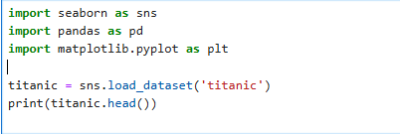

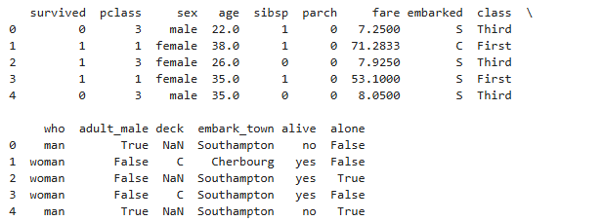

**i. Show the distribution of continuous variables using BoxPlot.**

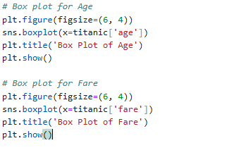

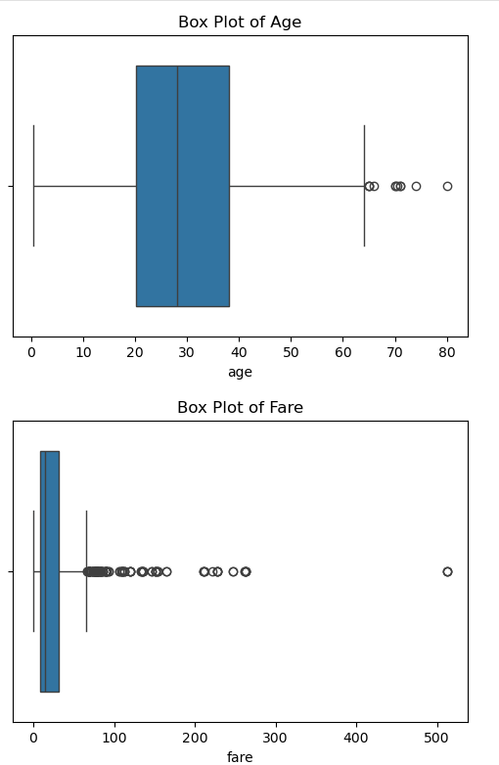

**ii. Identify the relationship between two continuous variables using scatter plot.**

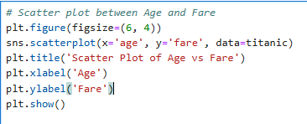

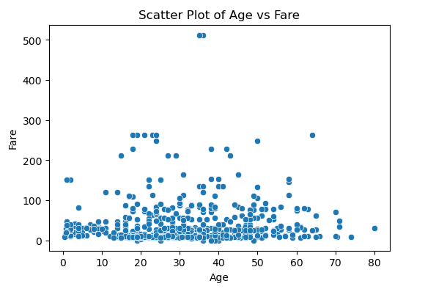

**iii. Find and display the frequency of the categorical values using count plot.**

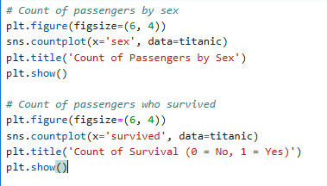

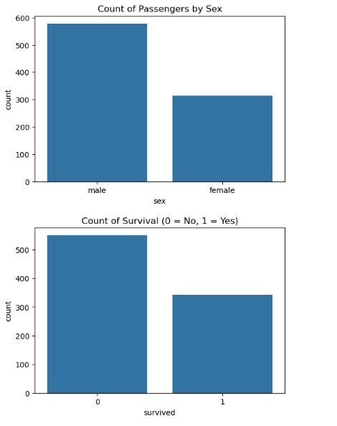 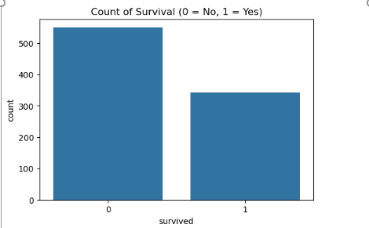

**iv. Apply point plots to display one continuous and one categorical variable.**

